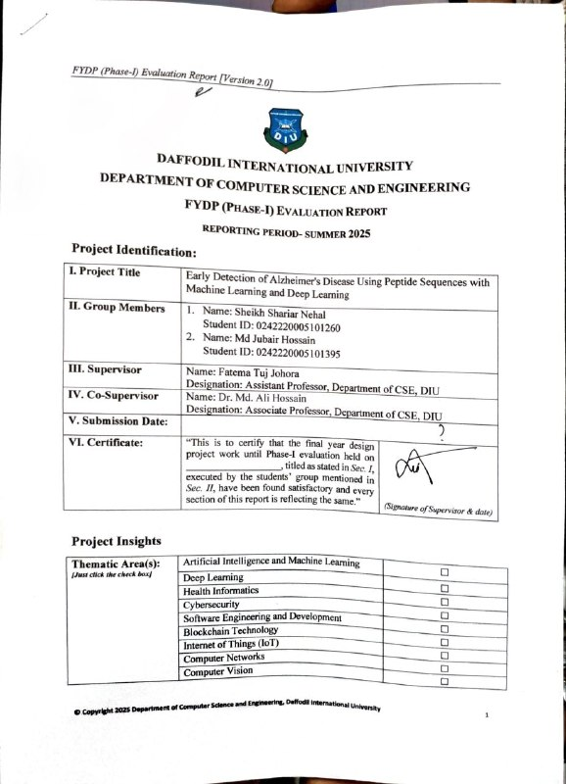

 | Robotics | ☐
 | Game Development | ☐
 | Cloud Computing | ☐
 | Image Processing | ☐
 | Others (please specify):
Software packages, tools, and programming languages | Python 3.x, pandas, numpy, scikit-learn, TensorFlow/Keras, matplotlib, seaborn, openpyxl, BeautifulSoup

CO Description for FYDP-Phase-I
CO | CO Descriptions | PO
CO4 | Perform economic evaluation, cost estimation, and apply suitable project management procedures throughout the FYDP lifecycle for the Alzheimer's peptide-sequence classification project. | PO11
CO6 | Select and apply appropriate methodologies, sequence encoding techniques, and contemporary ML/DL tools for predicting Alzheimer's-related peptide patterns. | PO5
CO7 | Assess societal, health, safety, legal, and ethical responsibilities in professional engineering practice related to AI-assisted Alzheimer risk prediction. | PO6
CO10 | Operate effectively as an individual and as a member/leader in multidisciplinary teams during FYDP. | PO9

- Project Overview

  - Introduction
Alzheimer's disease (AD) is a progressive neurodegenerative disorder that is currently considered one of the leading causes of dementia worldwide. This condition predominantly affects elderly patients, causing them to suffer from memory loss, cognitive impairment, and decreased ability to perform basic everyday activities. The global incidence of AD is continuously growing and significantly complicates current healthcare practices. Early diagnosis of the disease becomes essential, allowing healthcare professionals to delay its progression and improve the quality of life of their patients.
The current methods for diagnosing Alzheimer's disease include clinical examination and imaging analysis using various modalities such as MRI and PET scanning. Although these Methods can contribute to the accurate diagnosis of AD, but they are rather costly and lengthy and often allow detecting the disease only in its advanced stage when substantial brain damage has already occurred. Therefore, it becomes increasingly important to consider alternative approaches to this problem.
The recent developments in molecular biology have identified biomarkers in Alzheimer's disease patients in terms of aggregation of amyloid-beta (Aβ) peptides. As the sequence of a biomarker has significant biological properties and impacts its ability to aggregate, computing sequence data is an effective method to predict this disease at the earliest stage.
The emergence of artificial intelligence technology has introduced novel approaches to analysis of sequence data via machine learning (ML) and deep learning (DL) models. The classical ML models like logistic regression, random forest, and support vector machines (SVM) can help classify sequences according to certain characteristics. At the same time, advanced DL models like Convolutional Neural Networks (CNN) and LSTM can detect hidden sequence dependencies and provide more accurate classification results.
In this project, it is planned to conduct research aimed at creating a classifier capable of predicting Alzheimer's disease from sequence data of peptides. For this purpose, publicly available datasets such as CPAD 2.0 will be used, and both classical ML and DL models will be employed to classify sequences as amyloid and non-amyloid.

  - Background Study
Alzheimer's disease (AD) is an irreversible neurodegenerative disorder and the principal aetiology of dementia characterised by cognitive impairments, including memory loss and behavioural anomalies. Early discovery is crucial for the treatment of this disease; yet, current diagnostic techniques for Alzheimer's disease do not provide any substantial benefits for early-stage diagnosis.
Standard procedures applied for diagnosing AD include advanced imaging techniques like MRI and PET scanning. They do a good job of showing structural and functional aspects of the brain, but they have a lot of problems, such as being time-consuming, costly, and not always available. Consequently, other computational methodologies have been developed for effective early diagnosis.
In recent years, several biological investigations have revealed that Alzheimer’s disease is significantly linked with the irregular aggregation of amyloid-beta (Aβ) peptides. Peptides aggregate into plaques in the brain, which impair neuronee-to-neuronee interaction, causing neurodegeneration. Sequence characteristics play a crucial role in peptide aggregation; hence, sequence analysis is a promising research approach for the early diagnosis of diseases.
Due to recent progress in bioinformatics technology, machine learning (ML) methods have been utilised to investigate the biological aspects of diseases using peptide and protein sequences. analysis. Sequence classification methods, such as SVM, have proven to be successful in predicting disease biomarkers with accuracy rates as high as 85.7%.
Moreover, deep learning architectures like CNN and RNN have proven their effectiveness in representing complex sequences. Such architectures can identify local sequence motifs and long-term dependencies, which are critical for unravelling the processes involved in peptide aggregation. Additionally, neural networks can model sequence-phenotype relations and enhance prediction power even in the presence of missing experimental evidence.
Free-to-use databases such as CPAD 2.0 provide a wealth of peptide sequences for the development and evaluation of machine learning and deep learning algorithms. This work involves using both traditional machine learning algorithms (logistic regression, random forests, and support vector machines) and deep learning algorithms (CNN, LSTM, and bidirectional LSTM) to categorise peptide sequences as either amyloid or non-amyloid.

  - Gap Analysis
The existing limitations in current Alzheimer's disease (AD) diagnostics and computational solutions necessitate the development of more sophisticated, scalable, and precise ways to identify early-stage Alzheimer's. The primary limitations are the following:
Limitation/Challenge Area | Specific Gap/Shortcoming | Proposed Solution/Need
Conventional Diagnostics | It is costly and impractical for wide-scale or regular screening, and it detects changes only after substantial disease progression. | More sophisticated, scalable, and precise methods for identifying early-stage AD.
Computational Modeling of Peptides | Models fail to describe the intricate sequence-structure-function relationship within Aβ peptides. | Improved computational models to better capture complex peptide relationships.
DMS Experiments (as a data source) | Limited data coverage, noise, and insufficient combinations of mutations reduce its practical utility. | Techniques to overcome data limitations and noise from DMS experiments.
Previous ML Approaches | Reliance on manual feature extraction (e.g., amino acid composition), which may miss complex dependencies and correlations. | ML approaches that can automatically learn and capture complex dependencies between amino acids.
Model Comparison and Evaluation | Lack of a comprehensive comparison of classical ML and DL models using similar preprocessing methods and evaluation metrics. | A unified methodology to compare classical ML and DL frameworks using a prepared dataset (like CPAD 2.0) and consistent metrics.
Dataset Heterogeneity | Difficulties in evaluation due to differences in sequence length, class distribution, and preprocessing, especially with peptide datasets. | A standardised and prepared dataset (CPAD 2.0) for consistent and reliable model training and evaluation.

Therefore, this research suggests a method that unifies classical ML algorithms and DL frameworks using a prepared peptides dataset (CPAD 2.0). The use of this methodology will allow one to improve the efficiency and scalability of early Alzheimer's disease detection.

- Objectives
The primary objective of this project is to develop a reliable and scalable computational framework for the early detection of Alzheimer’s disease using peptide sequence data. The study aims to leverage machine learning and deep learning techniques to identify amyloid-related patterns from peptide sequences and support early-stage screening.

2.1 General Objective
The main objective is to design and implement an artificial intelligence-based system that can accurately classify peptide sequences into amyloid and non-amyloid categories for early Alzheimer’s disease detection.

2.2 Specific Objectives
- Getting the Data Ready
We'll gather peptide sequence data from trusted places like the CPAD 2.0 dataset. Then, We'll clean it up, remove duplicates, and make sure all the labels are consistent so the computer can learn properly.
- Translating Sequences into Computer Language
We need to turn the peptide sequences into a format computers can understand. We'll use methods like giving each amino acid a number (integer encoding), using a simple 'on/off' representation (one-hot encoding), or looking at how often certain amino acids appear (frequency-based representations) to prepare for model training.
- Building Basic Prediction Tools
We'll start by using standard machine learning tools like logistic regression, Random Forest, and support vector machine (SVM). These will give us a baseline to see how well we can predict Alzheimer’s.
- Creating Advanced Prediction Tools
The next step is to design and train more sophisticated deep learning structures, such as Convolutional Neural Networks (CNNs), Long Short-Term Memory (LSTM), and Bidirectional LSTM (BiLSTM). These are great at finding complex patterns in the sequences, which should boost our prediction accuracy.
- Testing the Tools and Seeing How They Perform
We'll test all the tools using standard measures like accuracy (how often it's right), precision (avoiding false positives), recall (avoiding false negatives), and F1-score (a balance of precision and recall). This ensures we can fairly compare all the different methods.
- Comparing the Basics vs. the Advanced
We'll directly compare the performance of the basic machine learning tools and the advanced deep learning models using the exact same data preparation and testing methods. This will help us pinpoint the best tool for the job.
- Making the Tools Smarter and Preventing Cheating
We'll apply techniques like stopping the training early, using regularisation (a way to keep the model simple), and fine-tuning the model's settings (hyperparameter tuning). This helps the model perform well on new, unseen data and prevents it from simply memorising the training data (overfitting).

- Methodology/ Requirement Specification:

  - Research Design/ Prototype Design
A quantitative experimental design was followed. The workflow consists of data preprocessing, sequence encoding, stratified train-test splits, multi-model training, metric-based evaluation, and model comparison visualisation. Early stopping was used in deep learning training to reduce overfitting risk.
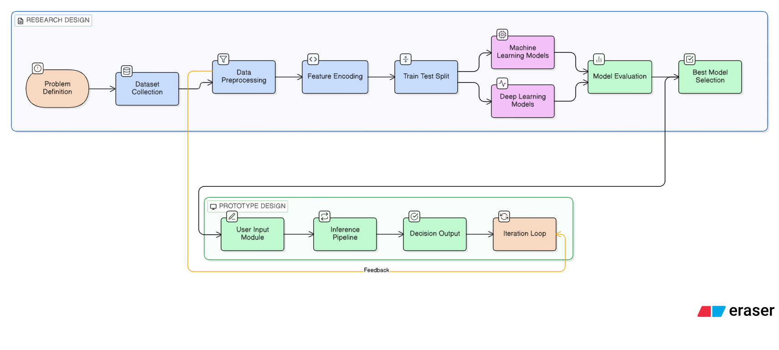

  - Data Collection/ Need Assessment
Data was downloaded programmatically from the CPAD 2.0 peptide repository (68 pages) and stored in CSV/XLSX. The final modeling dataset used in Phase-I contains 2001 peptide records after preprocessing. Each sample includes sequence information and class labels used for supervised classification.

  - Analysis Techniques
This section describes the analytical methods used in this study, including data preprocessing, feature extraction, model training, and evaluation techniques. The goal is to ensure that the peptide sequence data is properly prepared and analyzed to achieve accurate Alzheimer’s disease prediction.
3.3.1 Data Preprocessing
Data preprocessing is a critical step to ensure data quality and consistency before model training. The following preprocessing steps were applied to the peptide dataset:
- Data Cleaning: The dataset was filtered to retain only relevant attributes such as peptide sequences and class labels (amyloid and non-amyloid). Missing values and invalid entries were removed to maintain data integrity.
- Label Standardisation: Class labels were standardized into two categories: amyloid and non-amyloid, ensuring consistency across the dataset for binary classification.
- Duplicate Removal: Duplicate peptide sequences were identified and removed to avoid bias and overfitting during model training.
- Sequence Length Handling: Since peptide sequences vary in length, padding and truncation techniques were applied to ensure a fixed sequence length for deep learning models.
- Class Distribution Analysis: The dataset was analysed for class imbalance, and stratified data splitting was applied to maintain balanced class representation in training and testing sets.
3.3.2 Feature Encoding Techniques
To convert peptide sequences into machine-readable formats, the following encoding methods were used:
- Integer Encoding: Each amino acid was mapped to a unique integer value, enabling sequence representation for deep learning models such as LSTM and CNN.
- One-Hot Encoding: Peptide sequences were transformed into binary vectors representing amino acid positions, which were used for classical machine learning models.
- Sequence Padding: Encoded sequences were padded with zeros to ensure uniform input size across all samples, which is essential for neural network processing.
3.3.3 Model Training and Analysis
The processed dataset was used to train multiple machine learning and deep learning models:
- Machine Learning Models: Logistic Regression, Random Forest, and Support Vector Machine (SVM) were used as baseline classifiers to evaluate performance on structured features.
- Deep Learning Models: Convolutional Neural Networks (CNN), Long Short-Term Memory (LSTM), and Bidirectional LSTM (BiLSTM) were implemented to capture both local sequence patterns and long-range dependencies.
- Training Strategy: The dataset was divided into training and testing sets using a stratified split to ensure balanced class distribution. Early stopping techniques were applied in deep learning models to prevent overfitting.
3.3.4 Performance Evaluation Metrics
To assess model performance, standard evaluation metrics were used:
- Accuracy: Measures overall prediction correctness.
- Precision: Indicates the proportion of correctly predicted positive samples.
- Recall: Measures the ability to correctly identify positive cases.
- F1-Score: Provides a balance between precision and recall.
These metrics were used to compare all models and identify the most effective approach for Alzheimer’s prediction.
3.3.5 Comparative Analysis
A comparative analysis was conducted across all machine learning and deep learning models using the same dataset, preprocessing pipeline, and evaluation metrics. This ensures a fair comparison and helps determine the most reliable model for peptide-based Alzheimer’s detection.

- Progress Achieved:

  - Completed Tasks
- An automated downloader was developed for CPAD 2.0 peptide pages.
- The dataset was cleaned, and labels were standardized.
- Sequence integer encoding and one-hot representation were implemented.
- Three Machine Learning (ML) and three Deep Learning (DL) models were trained.
- A comparative performance chart was generated.
- The trained models and associated metadata were saved to ensure reproducible inference.

  - Results Obtained

Metric | CNN | BiLSTM | Logistic Regression | Random Forest | SVM | LSTM
Accuracy | 0.8329 | 0.8125 | 0.7916 | 0.7883 | 0.7869 | 0.7085
Precision | 0.8462 | 0.8125 | 0.7916 | 0.7883 | 0.7869 | 0.7085
Recall | 0.8500 | 0.8125 | 0.7916 | 0.7883 | 0.7869 | 0.7085
F1-score | 0.8481 | 0.8125 | 0.7916 | 0.7883 | 0.7869 | 0.7085

- Challenges Faced:
Extra caution was needed due to variable sequence length, class imbalance, and encoding selection. In order to train deep models without overfitting, the project also required stable package versions and sufficient computation time.
S.No. | Issues and Challenges | Strategies or Plans
1 | Variable peptide lengths | Use padding/truncation and keep the same sequence length across all models.
2 | Class imbalance in labels | Apply stratified splitting and monitor precision/recall alongside accuracy.
3 | Model overfitting | Use regularization, early stopping, and careful hyperparameter tuning.
4 | Environment and package consistency | Fix package versions and keep experiments in a reproducible notebook/script structure.

- Next Steps:
Tune hyperparameters, refine the encoding strategy, compare cross-validation results, finalize the best-performing model, and integrate the findings into the final report and presentation materials.
S.No. | Next Task | Estimate completion time  (MM-YY)
1 | Hyperparameter tuning and cross-validation for the best candidate models | 05-26
2 | Finalize feature encoding and threshold selection | 05-26
3 | Prepare comparison tables, figures, and error analysis | 05-26
4 | Integrate final findings into the report and slide deck | 06-26

- Updated Timeline:
The data preparation and baseline implementation phases are complete; model tuning, analysis, documentation, and final presentation preparation are in progress.
Tasks | Weeks
 | 6 | 7 | 8 | 9 | 10 | 11 | 12 | 13 | 14 | 15 | 16 | 17 | 18 | 19 | 20 | 21 | 22 | 23
Cleaning, deduplication, and preprocessing
Baseline ML training: Logistic Regression, Random Forest, SVM
LSTM and BILSTM development
Model saving, documentatin and report drafting

Estimated Work Period | 05-26 to 06-26
Actual Work Period | 05-26 to 06-26

- Resources Utilized:
Python, Jupyter Notebook, pandas, NumPy, scikit-learn, TensorFlow/Keras, Biopython, matplotlib, seaborn, python-docx, and the CPAD 2.0 dataset were used during this reporting period.

- Project Management and Financial Analysis:

- Future Considerations:
The project relies mainly on open-source software and publicly available data, so direct financial costs are minimal. The main management focus is on keeping the codebase modular, tracking experiments, and maintaining reproducible outputs for each model family.

- Conclusion:
In this work, we provide a computational framework for the early diagnosis of Alzheimer's disease based on peptide sequences and artificial intelligence methods. By utilizing the power of both machine learning (ML) algorithms and deep learning (DL) methods, our work shows that peptide sequences can be an effective tool for biomarker prediction related to Alzheimer's disease.
The entire framework of this project includes processes ranging from data cleaning and encoding to model construction and performance evaluation. The datasets from the CPAD 2.0 database have been preprocessed and converted to machine readable form through several encoding methods, such as integer encoding and one hot representation. Various models like logistic regression, random forest, support vector machine (SVM), convolutional neural network (CNN), long short-term memory (LSTM) and bidirectional LSTM (BiLSTM) have been built under the same standard metrics.
It is concluded from experiments that DL methods performed better than ML in prediction accuracy, especially for CNN and BiLSTM, because of their ability to capture complex dependencies in sequences.
In addition, the new strategy has several advantages compared to existing diagnostics tools like MRI and PET scans. First, it is affordable, scalable, and can be used for early prediction without conducting costly clinical tests. As a result, it can be effectively applied on a massive scale.
To summarize, the current research proves that the peptide sequence analysis along with AI algorithms can be regarded as an effective approach to detecting early signs of Alzheimer's disease. In addition, the proposed methodology creates a solid basis for future research and development. For example, clinicians can enhance existing models by implementing state-of-the-art architecture like transformers in practice.

References
[1] CPAD 2.0: Curated Protein Aggregation Database, “Peptide Dataset,” [Online]. Available: https://web.iitm.ac.in/bioinfo2/cpad2/peptides/

[2] F. Pedregosa et al., “Scikit-learn: Machine Learning in Python,” Journal of Machine Learning Research, vol. 12, pp. 2825–2830, 2011.

[3] M. Abadi et al., “TensorFlow: Large-Scale Machine Learning on Heterogeneous Systems,” 2015. [Online]. Available: https://www.tensorflow.org/

[4] S.-R. Yu et al., “Protein interaction prediction for Alzheimer’s disease using a multi-source protein features fusion framework,” Informatics and Health, vol. 2, pp. 119–129, 2025.

[5] A. Hassan et al., “A multimodal approach for Alzheimer’s disease detection and classification using deep learning,” Journal of Computational Biomedicine and Informatics, vol. 6, no. 2, Mar. 2024.

[6] P. Rani et al., “A machine learning model for Alzheimer’s disease prediction,” IET Cyber-Physical Systems: Theory & Applications, vol. 9, pp. 125–134, 2024.

[7] B. Wang et al., “Towards mechanistic models of mutational effects: Deep learning on Alzheimer’s A$\beta$ peptide,” Computational and Structural Biotechnology Journal, vol. 21, pp. 2434–2445, 2023.

[8] L. Xu et al., “An efficient classifier for Alzheimer’s disease gene identification", Molecules, vol. 23, no. 12, p. 3140, Nov. 2018.

[9] J. Hardy and D. J. Selkoe, “The amyloid hypothesis of Alzheimer's disease: Progress and problems on the road to therapeutics,” Science, vol. 297, no. 5580, pp. 353–356, Jul. 2002.

[10] D. J. Selkoe and J. Hardy, “The amyloid hypothesis of Alzheimer's disease at 25 years,” EMBO Molecular Medicine, vol. 8, no. 6, pp. 595–608, Jun. 2016.

[11] H. Braak and E. Braak, “Neuropathological staging of Alzheimer-related changes,” Acta Neuropathologica, vol. 82, no. 4, pp. 239–259, 1991.

[12] C. R. Jack Jr. et al., “NIA-AA Research Framework: Toward a biological definition of Alzheimer's disease,” Alzheimer’s & Dementia, vol. 14, no. 4, pp. 535–562, Apr. 2018.

[13] A. Fernandez-Escamilla et al., “Prediction of sequence-dependent and mutational effects on the aggregation of peptides and proteins,” Nature Biotechnology, vol. 22, no. 10, pp. 1302–1306, Oct. 2004.

[14] W. McKinney, “Data structures for statistical computing in Python,” in Proc. 9th Python in Science Conf., 2010, pp. 56–61.

[15] C. R. Harris et al., “Array programming with NumPy,” Nature, vol. 585, no. 7825, pp. 357–362, 2020.

[16] J. D. Hunter, “Matplotlib: A 2D graphics environment,” Computing in Science & Engineering, vol. 9, no. 3, pp. 90–95, 2007.

[17] M. L. Waskom, “Seaborn: Statistical data visualization,” Journal of Open Source Software, vol. 6, no. 60, p. 3021, 2021.

[18] L. Richardson, “Beautiful Soup Documentation,” [Online]. Available: https://www.crummy.com/software/BeautifulSoup/bs4/doc/

[19] openpyxl Developers, “openpyxl documentation,” [Online]. Available: https://openpyxl.readthedocs.io/

Appendix
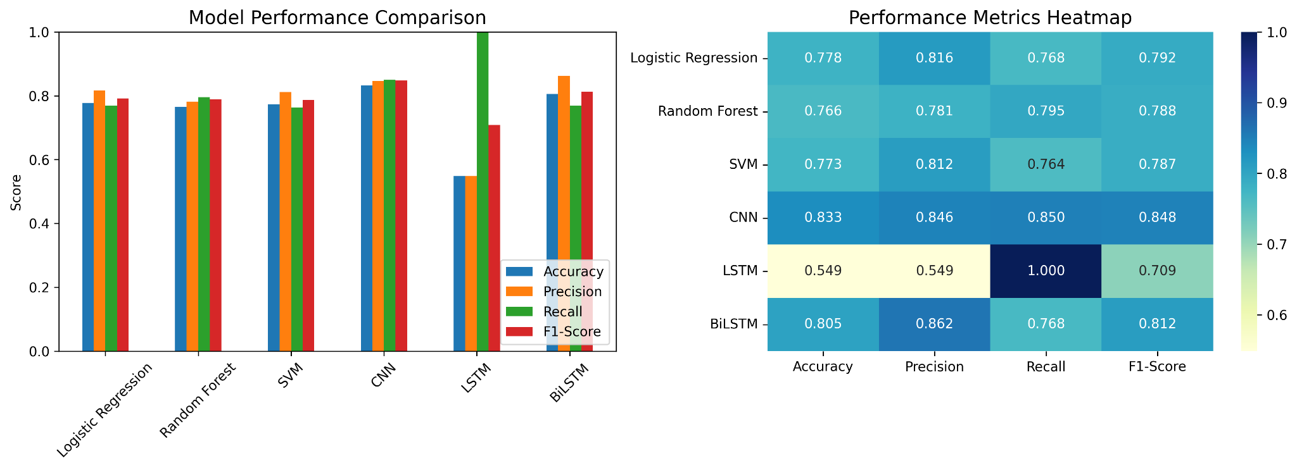
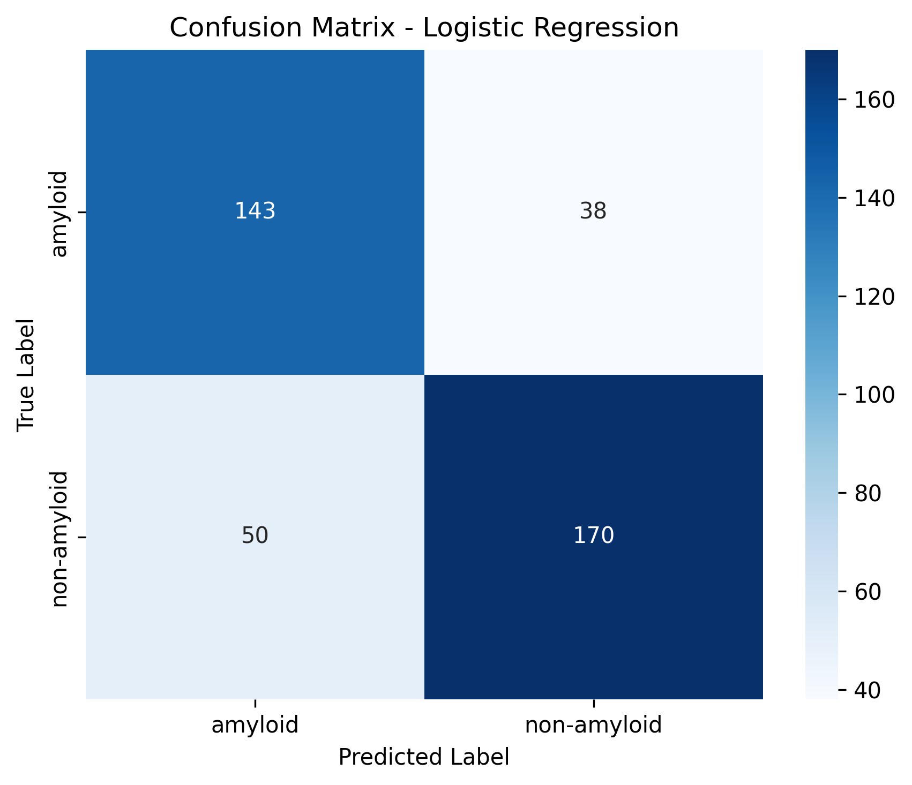
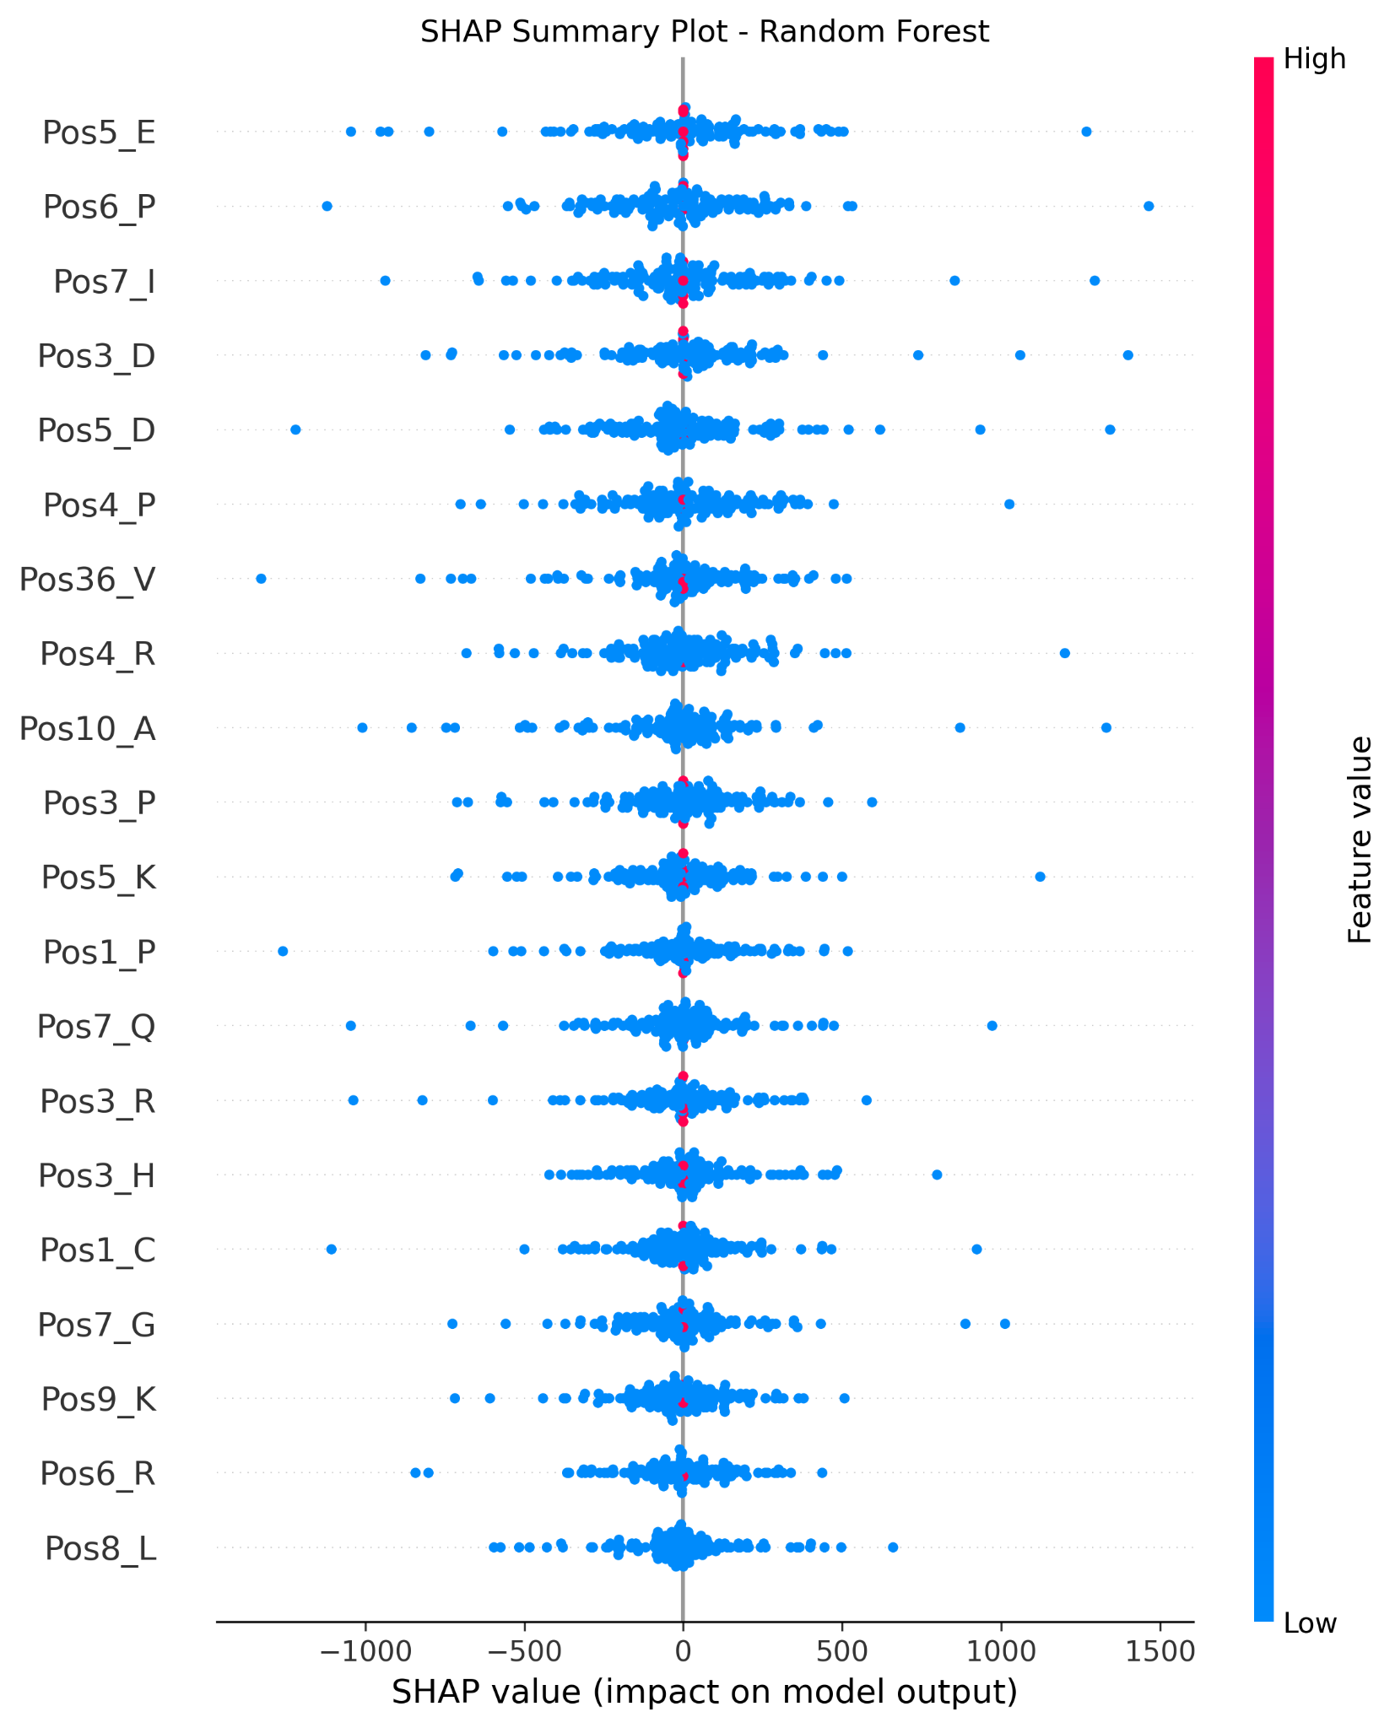

FINAL YEAR DESIGN PROJECT
PHASE-I PROGRESS REPORT

This report, in the form of a template, has been specifically designed for BSc. students working on their Final Year Design Project (FYDP) at Computer Science and Engineering Department, Daffodil International University (DIU).

Every group of students is required to do the following:
- Complete all the sections of this template
- Get it certified by the assigned supervisor before one week of Phase-I evaluation presentations
- Submit 01 photocopy to each of the following, on or before the day of Phase-I presentations:
  - Supervisor
  - Internal Evaluator
- Submit original copy to FYDP committee on the day of Phase-I presentations.

Note:
- Use English
- There should be NO grammatical or spelling mistakes
- Submission after due date will not be accepted
- For more information, contact your Supervisor

Template prepared by:  FYDP Committee  Dept. of CSE, DIU | Template approved by:  Dr. Sheak Rashed Haider Noori  Professor and Head, Dept. of CSE, DIU

The students and faculty members of Computer Science and Engineering Department, Daffodil International University have full access rights to read and print this document without any prior notice to the Head and FYDP committee.

All rights are reserved.

